Release 1 Strategic Analysis and Release 2 Improvement Proposal
For Sprint Review on Wednesday 14 October 2026

1 Scope and review boundary
The strategic models show only functions that are present in the current Release 1 package. The detailed BPMN contains six executable processes: the integrated master process plus referral, appointment, finance, treatment, and enquiry/clinic-letter processes. The source package also contains Camunda Forms and seven Java external-worker job types. The diagrams below therefore describe the current increment, not the full case-study ambition.

2 Strategic BPMN model of Release 1
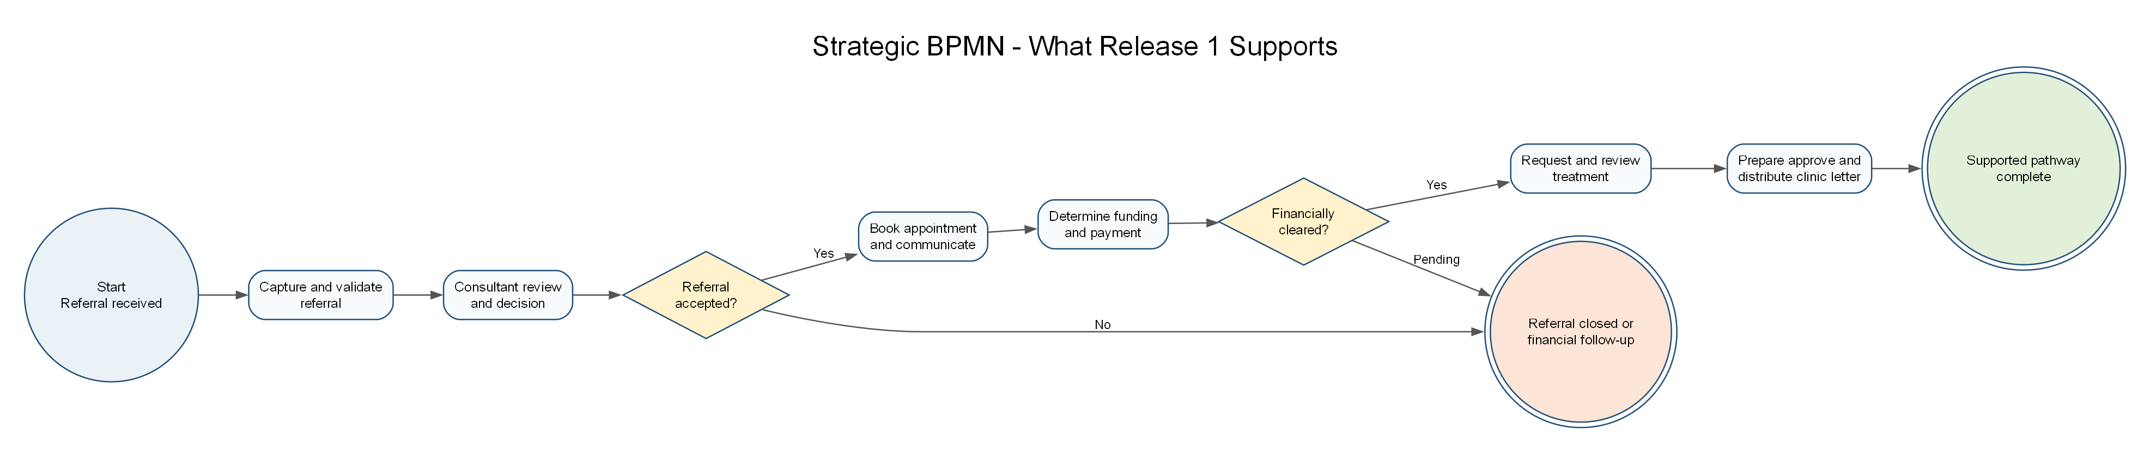
Figure 1. High-level stages supported by the current Release 1.

3 i star Strategic Dependency model
The current SD model has six actors: Patient and Referrer; Referral and Consultant Review; Appointment and Patient Communication; Finance; Treatment and Chemotherapy; and Enquiry Clinic Letter and Monitoring. Each dependency identifies a concrete dependum and the actor that relies on it.
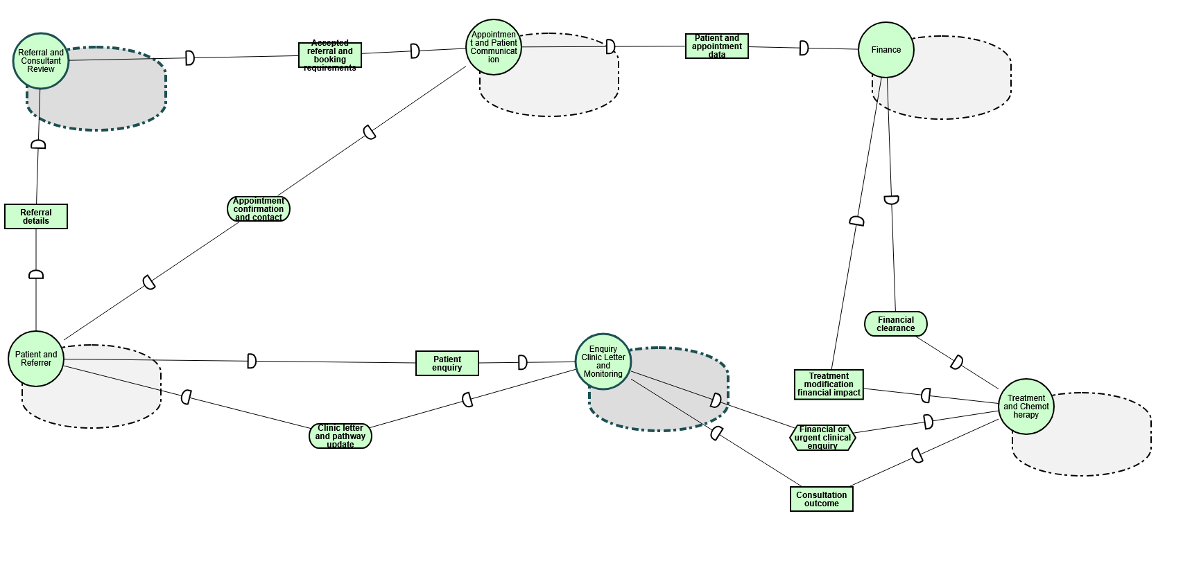
Figure 2. Current Release 1 strategic dependencies across six actors.
The ten current dependencies are Referral details; Accepted referral and booking requirements; Appointment confirmation and contact; Patient and appointment data; Financial clearance; Treatment modification financial impact; Consultation outcome; Patient enquiry; Clinic letter and pathway update; and Financial or urgent clinical enquiry. These dependencies connect the operational ownership areas: referral information is validated and accepted before booking, appointment data supports financial routing, financial clearance supports treatment, consultation outcomes support clinic letters, and patient enquiries or pathway updates return to the patient and referrer.

4 i star Strategic Rationale model
The SR model explains the internal rationale for the same five operational actors, while Patient and Referrer remains an external actor. Referral and Consultant Review pursues a safe referral decision and complete, traceable referral; Appointment and Patient Communication pursues a timely confirmed appointment and clear patient communication; Finance pursues financial clearance before treatment and avoidance of duplicate charge; Treatment and Chemotherapy pursues safe and appropriate treatment and clinical safety; and Enquiry Clinic Letter and Monitoring pursues accurate and timely patient updates and timely, clear communication.
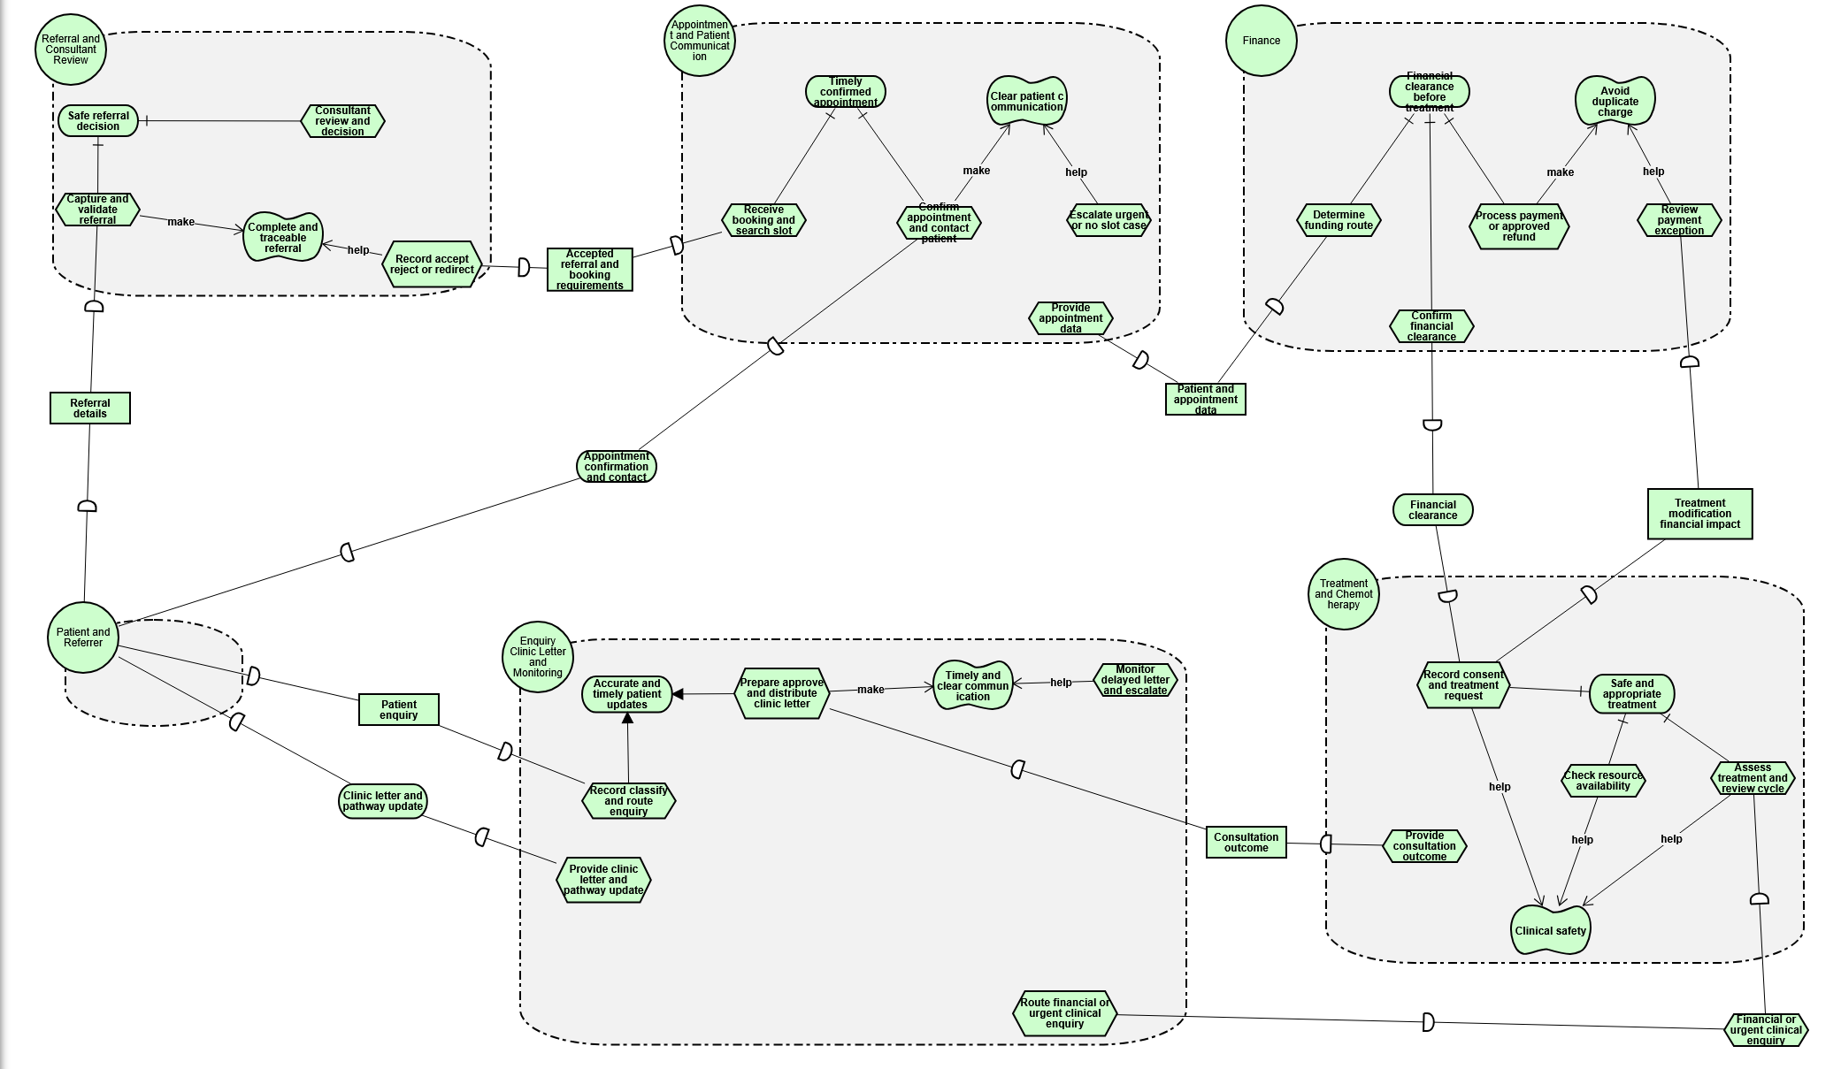
Figure 3. Current Release 1 strategic rationale, goals, qualities and tasks by actor.
The refinement and contribution links in the current diagram are deliberate. Capture and validate referral plus consultant review and decision AND-refine Safe referral decision. Receive booking and search slot plus confirm appointment and contact patient AND-refine Timely confirmed appointment. Determine funding route, process payment or approved refund, and confirm financial clearance AND-refine Financial clearance before treatment. Record consent and treatment request, check resource availability, and assess treatment and review cycle AND-refine Safe and appropriate treatment. In the enquiry area, preparing and distributing a clinic letter OR recording, classifying and routing an enquiry can achieve Accurate and timely patient updates. Contribution links connect tasks to qualities, for example escalation supports clear communication, payment processing and exception review support avoiding duplicate charge, and treatment tasks support clinical safety.

5 Evidence-based evaluation of Release 1
Area | Release 1 evidence | Strength | Limitation or gap to validate
Referral and clinical decision | Process_Referral; referral intake and consultant-review forms; validate-referral-reference worker | Referral is validated before consultant decision and an acceptance decision gates appointment progression. | No evidence yet of a live external referral source or identity/RBAC enforcement.
Appointment and communication | Process_Appointment; booking/contact forms; scheduling and letter workers | Slot availability, two-week contact rule, no-slot and contact outcomes are modelled. | Scheduling and correspondence services are explicitly simulated; end-to-end runtime proof remains required.
Finance and safety | Process_Finance; payment/refund workers; five added finance outcome forms | Payment status branches include confirmation loss and duplicate-risk investigation; refund is approval-gated. | No persistent audit store or verified payment-provider integration is in this release.
Treatment | Process_Treatment; consent/request/cycle forms; resource worker | Human clinical judgement and resource availability are separated from automation. | Treatment authorisation is captured as workflow data; stronger role-based authorisation needs a Release 2 design.
Clinic letters and monitoring | Process_EnquiryLetter; approval/monitoring forms; letter worker | Clinical approval occurs before distribution and monitoring paths are represented. | Timed reminders/escalations need broker runtime demonstration, and delivery is simulated.
Configuration consistency | Offline validator: 6 BPMN, 19 Forms, 7 job types | XML/JSON, form bindings, call targets and worker job-type references passed offline validation. | Static success is not the same as a deployed Camunda execution.

6 Proposed Release 2 improvements
Priority | Improvement action | Reason from V1 evaluation | Acceptance evidence
P1 | Run normal and exception journeys in the teaching Camunda environment and retain task/worker evidence. | Current validation is structural; a broker execution is still required. | Deployment version, completed task screenshots/logs, worker output and result for one normal and one exception case.
P1 | Add RBAC and a durable audit trail design for consultant, clinician and finance approvals. | V1 models responsibility but does not prove authenticated authorisation or audit persistence. | Role matrix, access design, audit fields and an approval-rejection test.
P1 | Replace simulated integration boundaries with adapter contracts and failure/retry policy. | Workers identify themselves as simulated external services. | API contract stubs, timeout/error mapping and non-production-data statement.
P2 | Strengthen form accessibility with help text, error-message review, keyboard-only check and language/support preference. | Labels and required checks exist; user-centred testing is not yet evidenced. | Accessibility checklist and observed user-task test results.
P2 | Make monitoring time-based and measurable. | The BPMN includes monitoring paths, but timers and operational measures require demonstrated configuration. | Timer configuration, reminder/escalation evidence and a monitored-age test.

